To use the call out feature you first need to create a new Sentai routine. We take you through this process in this guide and on screen.

Select Account menu in the bottom right hand corner and then the Call out option | 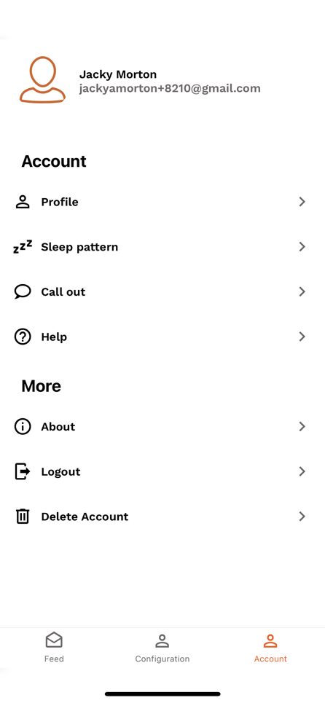
Add the name of the contact who will be the primary contact when the person using Sentai calls out and click on Let’s get started which will open an Alexa app screen | 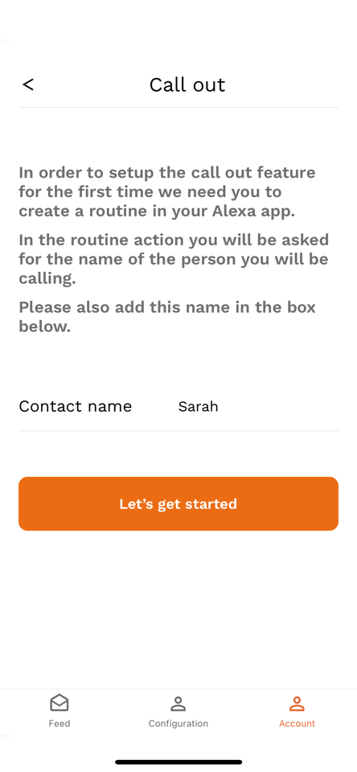
Select View Routine | 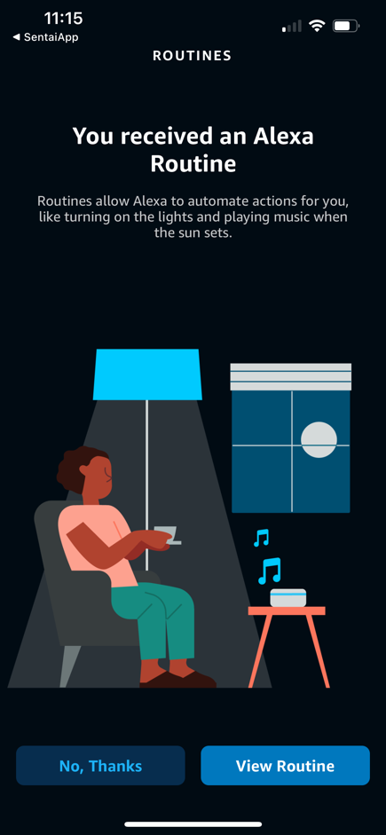
You will now see this screen | 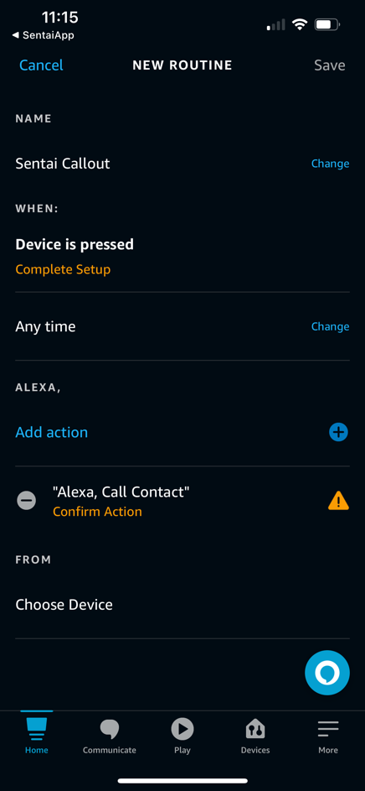
Select Device is pressed – Complete Setup and then pick Sentai Call | 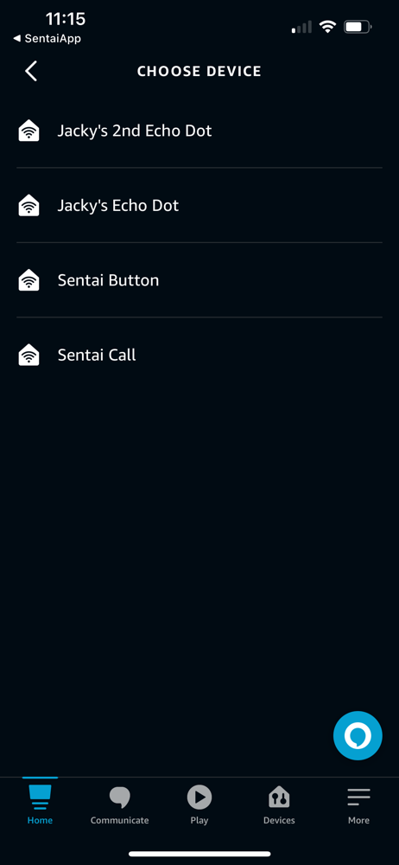
Save | 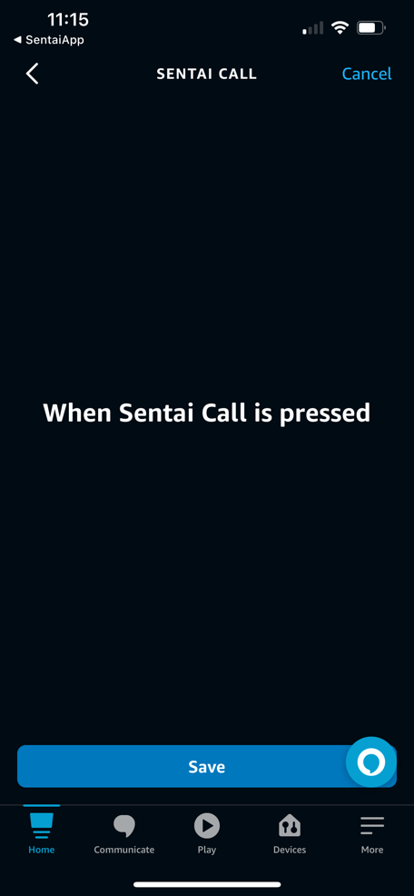
You will now be back to this screen and need to select Alexa, Call Contact – Confirm Action | 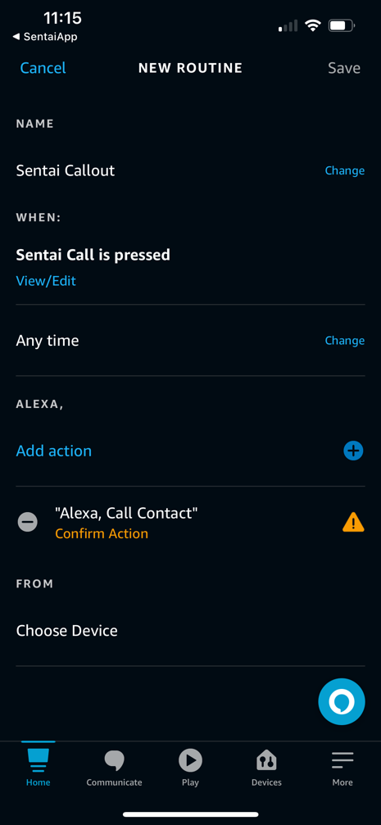
Amend Call Contact to Call <name>, this is the same name as the primary contact you added to the Sentai app screen at the start of this process  Then select Confirm in the top right hand corner | 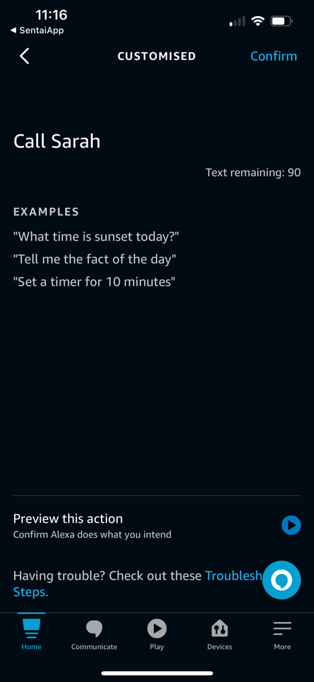
You will be back to this screen and finally need to select Choose Device | 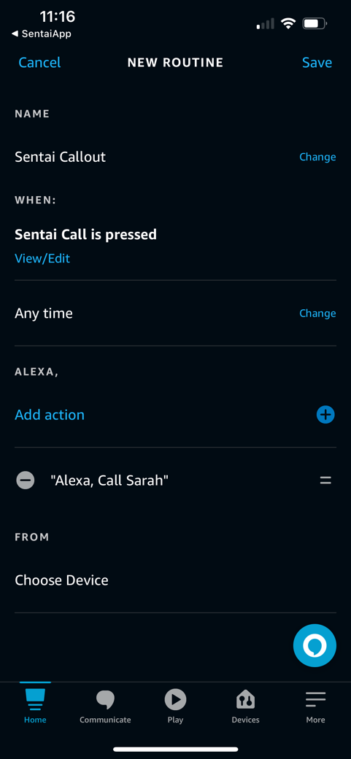
Pick the device that Sentai uses to talk | 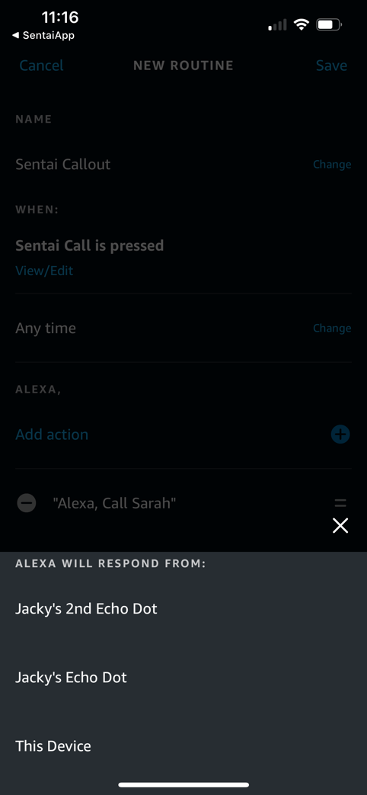
Save (top right) and ensure you see a blue banner confirming the routine has saved | 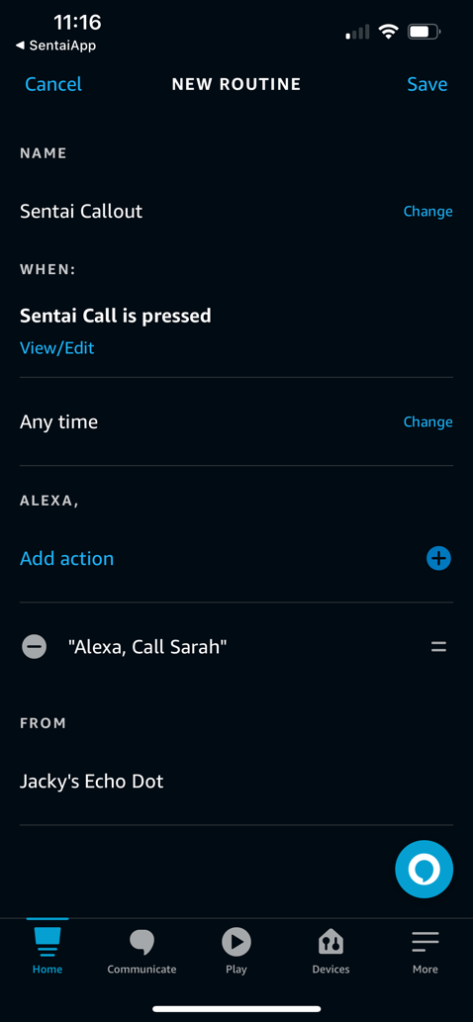
You should now see this (you may have other routines set up and see a long list, please ensure you can see both Sentai routines) | 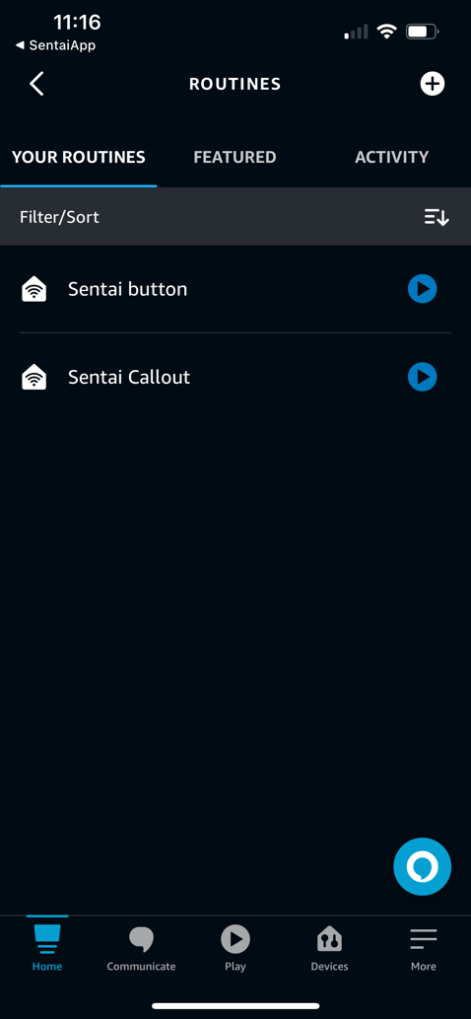
You can now close the Alexa app and go back to the Sentai app

